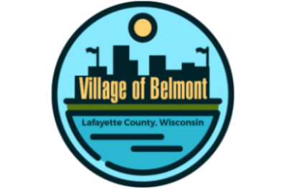
Village of Belmont
222 S. Mound Ave., Belmont, WI
REGULAR BOARD MEETING
in the Community Building

WEDNESDAY, JUNE 21, 2023 @ 7 PM
AGENDA

- CALL TO ORDER
- PLEDGE OF ALLEGIANCE
- ROLL CALL
- VERIFICATION OF PROPER NOTICE
- CONSIDERATION OF CONSENT CALENDAR
(The following items may be approved on a single motion & vote due to their routine nature. Please indicate to the Village President if you would prefer separate discussion & action.)
- Approve Agenda
- Approve Minutes of Previous Meeting(s)
- Clerk-Treasurer’s Financial Report
- Payment of Bills
- CITIZEN’S COMMENTS, OBSERVATIONS AND PETITIONS, if any
- VILLAGE OFFICIAL’S REPORTS
- President
- Engineering Consultant, Dan Dreessens, Delta 3 Engineering
- Director of Public Works
- Clerk-Treasurer
- Police Department
- Trustee(s):
- COMMITTEE & COMMISSION MEETING REPORT(S)
- Tourism Commission Meeting – June 13, 2023
- OLD BUSINESS
- NEW BUSINESS
- Discussion and or Action
- Action if any, for the Tourism Commission Meeting.
- Resolution #6-21-2023 for 2022 Compliance Maintenance Annual Report (CMAR)
- 2023-2024 Mobile Home Park License
- 2023-2024 Salvage Yard License
- 2023-2024 Cigarette Licenses
- 2023-2024 Liquor Licenses
- 2023-2024 Operator’s License
- Information of Upcoming Discussion and/or Action Items and Meetings
- ADJOURNMENT
Julie Abing, Clerk-Treasurer
Posted: Tuesday, June 20, 2023

Please note that, upon reasonable notice, efforts will be made to accommodate the needs of disabled individuals through.
appropriate aids and services. For additional information or to request this service, contact the Village Office by calling 762-5142.
Posted at: Belmont Post Office, Mound City Bank, Community Building, Message Center around corner from Village Office Door and on
website: www.belmontwi.com.

